Keys generation instructions
After keys generation software start you will get the following window:
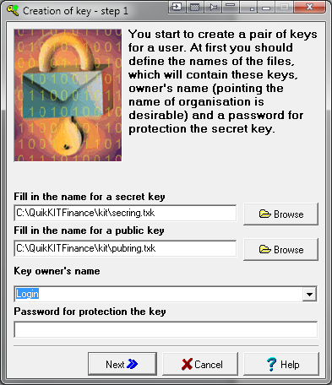
Path to the folder where you will store key files should be specified in the fields “Fill in the name for a secret key” and “Fill in the name for a public key”. The file path shouldn’t contain spaces or any special symbols.
After that a name should be entered to the field “Key owner’s name”. This name will be your login name in future. This word should be entered using Latin letters only.
Enter your password into the field “Password for protection the key” (is should be at least 5 symbols long), it will be used to login into the system. After filling in of all the fields you have to click “Next”
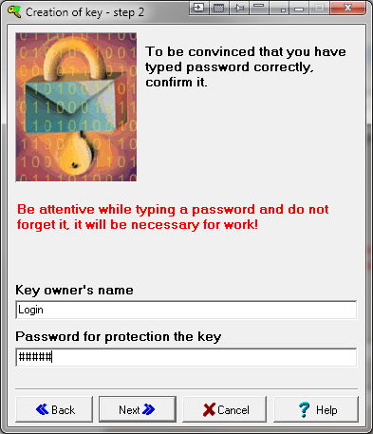
Enter your password again to confirm and then click “Next”. If the password has been entered incorrectly system won’t allow you to continue. In that case you will need to click “Back” and repeat Step 1.
It is necessary to remember your login name and password which are entered during the keys generation procedure as you will use them for system authorization.

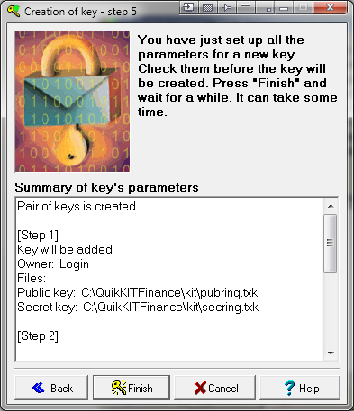
After getting that window click “Finish”. You will get the following window:
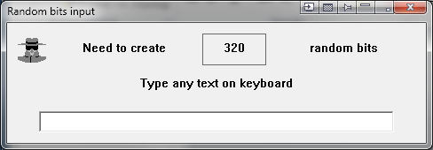
Type random symbols before the next window will appear.
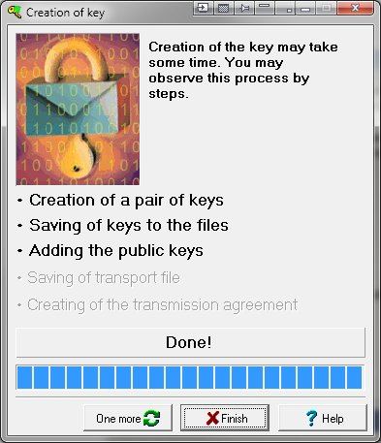
Then you have to click “Finish”. Two files have been created: pubring.txk and secring.txk
The public key file pubring.txk file needs to be sent to the EMAIL: support@brokerkf.ru
Please ensure that your name or organization name, as well as the number of the brokerage services agreement (i.e. your account number) are also included into the message. After receiving the key, we will register you in the system.
Attention!
Key files should be sent from those email addresses, which are claimed in the identification documents.

